PROJECT AIRBNB

STUDENT ID NUMBER :1000066898

ROSARIO PAVONE

INDEX

1.Definition of Facts, Dimensions, and Measures for the Airbnb Examples 2

1.1 Data Files Description 4

1.2 Creating Derived Fields 4

1.3 Aggregation and Grouping4

1.4 Integrating Cost and Rent Prices…………………………………………………………………………………….. 5

1.5 Financial Calculations…………………………………………………………………………………………………5

1.6 Airbnb-Specific ………………………………………………………………………………………………………5

1.7 Yield Calculations…………………………………………………………………………………………………….5

2. Description of the OUTPUT File 6

**3.Description of the ETL Operations for Airbnb Dataset**7

3.1 Data Extraction (Extract)7

3.2 Data Cleansing and Transformation (Transform)……………………………………………………………………...7

3.3 Combining Data (Load)……………………………………………………………………………………………….7

3.4 Incorporating "Occupancy Rate by City"……………………………………………………………………………..8

**4.Summary of the First Steps**9

4.1 Top 10 cities based on  ADJ_AIRBNB_YROI 9

4.2 Top 10 cities based on RENT_YROI 10

4.3 Top 5 types of house based on  ADJ_AIRBNB_YROI …………………………………………………………......13

* 1. Top 5 types of house based on  RENT_YROI……………………………………………………………………………………………………14
  2. Comparison with Adj_Airbnb_YROI Results………………………………………………………………………………………………………………..…..15

**5.Additional Summary Charts…………………………………………………………………………………………17**

5.1 The top 5 types of houses in terms of ADJ_AIRBNB_YROI (consider only types with more than 20 samples) for the top 5 cities based on the Occupancy Rate…………………………………………………………………………….17

5.2 The top 5 cities in terms of  Occupancy Rate (consider only cities with more than 300 houses) for the top 5 types of house based on the ADJ_AIRBNB_YROI/RENT_YROI. ……………………………………………………………...20

**6.Optimizing Real Estate Investments: Strategic Allocation of 1.2M Budget Across Multiple Cities……………23**

**Introduction**

This dataset provides a comprehensive overview of hosts, geographical availability, and crucial metrics for making informed predictions and strategic decisions in the realm of Sicilian real estate. By delving into the intricate details of each variable, we aim to gain valuable insights into the behavior of hosts, areas, and the dynamics of the market.

Objectives: This project seeks to conduct a thorough descriptive and exploratory analysis of the dataset, shedding light on individual variable behavior as well as their interplay. By unraveling patterns and trends, we aim to generate hypotheses that can inform future decision-making processes. The analysis will be presented in a clear and structured manner, serving as a practical guide for understanding and interpreting the data.

Methodology: The analysis will employ common statistical techniques such as variable classification, frequency distribution tables, histograms, and measures of central tendency. Each topic covered in the analysis will be outlined to provide clear guidance for conducting a comprehensive study of the dataset.

Project Description: This report examines various properties across different cities in Sicily, with a focus on identifying lucrative investment opportunities. Key metrics including property size, rental income, property price, local taxes, and return on investment will be evaluated to assess the potential of each property. Through this analysis, we aim to provide insights that can guide investors in making informed decisions in the Sicilian real estate market.

**1.Definition of Facts, Dimensions, and Measures for the Airbnb Examples**

In this step, we will systematically integrate and analyze the data from three distinct files: "House Info," "Airbnb Price," and "Cost and Rent Prices (BUY and RENT)." The primary objective is to create a comprehensive dataset that can be utilized to determine the optimal type of house to purchase and its corresponding location based on several financial metrics.

**1.1 Data Files Description**

House Info:

Fields: ID, Number of Bedrooms, Number of Bathrooms, City

Purpose: Provides foundational data on the structural details and locations of houses.

Airbnb Price:

Fields: ID, Price per Night

Purpose: Contains financial information pertaining to the nightly rental price of houses listed on Airbnb.

Cost and Rent Prices (BUY and RENT):

Fields: City, Rent Cost, Buy Cost

Purpose: Offers insights into the rental and purchase costs associated with different cities.

Procedure

1. Merging Datasets

The initial task involves merging the "House Info" and "Airbnb Price" datasets. This join operation will leverage the common ID field to correlate each house with its respective Airbnb rental price per night. This integration is essential for associating housing details with their financial metrics.

**1.2 Creating Derived Fields**

House Type:

A new field, HOUSE_TYPE, will be created by concatenating the number of bedrooms and bathrooms. This combined metric provides a unique identifier for different house configurations, facilitating more nuanced analysis.

House Size:

The HOUSE_SIZE field will be computed using a predefined formula discussed during previous lectures. This metric is pivotal for standardizing house dimensions and enabling consistent comparisons across different properties.

The augmented House Info dataset will now comprise the following fields:

ID, HOUSE_TYPE, HOUSE_SIZE, PRICE_PER_NIGHT, CITY

**1.3 Aggregation and Grouping**

To inform our decision-making process regarding house purchases, we need to aggregate the data by HOUSE_TYPE and CITY. For each group:

Calculate the average HOUSE_SIZE.

Calculate the average PRICE_PER_NIGHT.

Compute the count of houses (number of rows) for each type in each city, denoted as NUMBER_AIRBNB_HOUSE.

The resultant dataset should include:

CITY, HOUSE_TYPE, AVG_HOUSE_SIZE, AVG_PRICE_PER_NIGHT, NUMBER_AIRBNB_HOUSE

**1.4 Integrating Cost and Rent Prices**

The next step is to integrate this aggregated data with the "Cost and Rent Prices" dataset. This join operation will be based on the CITY field. It's crucial to resolve any discrepancies in city names (e.g., 'Cefal' vs. 'Cefalù') to ensure comprehensive data integration.

**1.5 Financial Calculations**

Utilizing the integrated dataset, we will perform the following calculations:

Annual Rent:

 (AVG_HOUSE_SIZE * RENT *12)

House Price:

\text{HOUSE_PRICE} =  (AVG_HOUSE_SIZE * PRICE)

Local Annual Taxes:

(HOUSE_PRICE*0.015)

**1.6 Airbnb-Specific Calculations**

The Airbnb occupancy rate is defined as 35% plus the last digit of the student's ID number.

Annual Airbnb Rent:

AVG_PRICE_PER_NIGHT*365* AIRBNB_OCCUPANCY_RATE

Airbnb Service Cost:

AIRNBN_SERVICE_COST = ANNUAL_AIRBNB_RENT * (0,03 + (THE SECOND LAST DIGIT OF YOUR STUDENT ID NUMBER/300))

**1.7 Yield Calculations**

Rent Yield on Investment (RENT_YROI):

(ANNUAL_RENT-LOCAL_ANNUAL_TAXES) /  HOUSE_PRICE

Airbnb Yield on Investment (AIRBNB_YROI):

(ANNUAL_AIRBNB_RENT - AIRNBN_SERVICE_COST - LOCAL_ANNUAL_TAXES)  /HOUSE_PRICE

**2. Description of the OUTPUT File**

The output file from Tableau Prep serves as a crucial initial step in the data analysis process, offering a comprehensive snapshot of Airbnb property data across various cities. Each entry in the file corresponds to a specific property listing and provides a rich array of information essential for understanding the dynamics of the real estate market.

Starting with financial metrics, the file encompasses key indicators like Airbnb yield, rental yield, house price, and local annual taxes. These metrics offer a nuanced perspective on the profitability and financial viability of Airbnb investments in different locales. They enable investors to gauge potential returns, assess risks, and make informed decisions about property acquisition and management.

Moreover, the dataset includes details on the number of Airbnb properties available in each city, shedding light on market saturation and competition levels. This information is invaluable for identifying emerging trends, spotting lucrative investment opportunities, and devising effective marketing strategies to maximize property occupancy and rental income.

Furthermore, the file provides insights into property characteristics such as average house size, house type, and average price per night. These details offer a glimpse into the preferences of Airbnb guests and help property owners tailor their listings to meet market demand effectively. Understanding the correlation between property attributes and rental performance is crucial for optimizing listing quality and enhancing the overall guest experience.

By leveraging data visualization tools like Tableau Desktop, analysts can delve deeper into the dataset, uncover hidden patterns, and visualize trends through interactive charts, graphs, and maps. This visual exploration facilitates intuitive comprehension of complex datasets, enabling stakeholders to derive actionable insights and formulate data-driven strategies for success in the Airbnb rental market.

In essence, the output file serves as a foundational resource for comprehensive data analysis, empowering stakeholders to navigate the intricacies of the Airbnb ecosystem, capitalize on emerging opportunities, and drive sustainable growth in the real estate sector.

**3.Description of the ETL Operations for Airbnb Dataset**

In the context of the Airbnb dataset, the ETL (Extract, Transform, Load) process is fundamental for aggregating, cleaning, and structuring data from various sources, facilitating analysis and decision-making. Here’s how the ETL operations are applied to the Airbnb dataset:

#### 3.1 Data Extraction (Extract)

* **Extraction of Files from Multiple Sources**: The ETL process begins with extracting data from multiple source files containing information about Airbnb properties. These files include details such as rental yield, house price, occupancy rate by city, and other relevant attributes. The extraction of the files was performed using the Output function available in Tableau Prep, allowing me to transform the files into an Excel sheet, making them easily manageable in Tableau Desktop.
* **Identification and Access to Sources**: These source files were identified as originating from internal databases and external data providers, including CSV files, JSON files from APIs, and database exports.
* **Extraction Frequency**: Data extraction is performed weekly to ensure the dataset remains up-to-date and reflects the latest market conditions.

#### 3.2 Data Cleaning and Transformation (Transform)

* **Data Cleaning and Standardization**: Once extracted, the data is cleaned and standardized to remove inconsistencies, errors, or missing values, ensuring data quality and consistency across all records. Special attention was given to property names, especially those with apostrophes or accents, to ensure correct visualization.
* **Handling Missing Values**: Missing values were managed through imputation with mean values, flagging for review, or exclusion, depending on the context and importance of the missing data.
* **Transformation of Data Types and Units**: Data types and units were standardized to ensure uniformity and compatibility. Outliers were analyzed and addressed, and the data was converted into a consistent format for further processing.
* **Data Validation Rules**: Specific validation rules were applied to verify the correctness of data formats, ranges, and dependencies between different data fields.
* **Data Enrichment**: The dataset was enriched by incorporating additional information from external sources or performing calculations to derive new insights. For example, combining property details with occupancy rates to provide a comprehensive view of Airbnb properties.
* **Derived Calculations and Metrics**: Calculations such as the Adjusted Airbnb YROI were performed using raw rental yield data combined with additional cost factors.

#### 3.3 Data Loading (Load)

* **Integration of Multiple Data Sources**: The ETL process integrates data from various sources by performing joins, unions, or merges based on common identifiers such as property IDs or city names. This ensures a comprehensive dataset with information from multiple perspectives.
* **Aggregation and Synthesis of Information**: Aggregations were performed to synthesize information at different levels, such as calculating average rental yields or occupancy rates for each city. These aggregated data points provide valuable insights for analysis. The first join was created between 'Data' and 'Price', using 'ID' as the linking variable. After aggregating all necessary variables, another join was performed with 'Cities in Sicily by Rent', linking 'Comuni' with 'Città'. Only the 'Città' field was retained, and the 'Comuni' field was eliminated. Subsequently, a new output was generated as an Excel file named 'Airbnb_Pavone_Step(1,2,3)'. At this point, the focus shifted to Tableau Desktop.
* **Data Storage and Access**: The integrated dataset is stored in a cloud-based data warehouse, allowing easy access and querying for further analysis and visualizations in Tableau.
* **Optimization Techniques**: Indexing and partitioning techniques were applied to the data warehouse to improve the performance of data loading and querying processes.
* **Validation of Combined Data**: Post-combination validation checks ensured that joins, merges, and unions were successful and accurate, without any data loss or corruption.
* **Dataset Structuring**: The dataset was structured in a format suitable for analysis and visualization. Pivoting or reshaping operations were applied to organize the data, making it more accessible and interpretable. Some variables were maintained in rows or columns directly in Tableau Desktop to facilitate various visualizations. Initially, many outputs were visualized with horizontal bar charts instead of vertical ones, providing a more accurate view of the data.

### Conclusion

The ETL process for the Airbnb dataset is designed to ensure the quality, consistency, and usability of data for analysis. By carefully examining the extraction, transformation, and loading of data, we can gain significant insights that inform strategic decisions in real estate investments.

**4.Summary of the First Steps**

**4.1 Top 10 cities based on  ADJ_AIRBNB_YROI (consider only cities with more than 300 houses)**

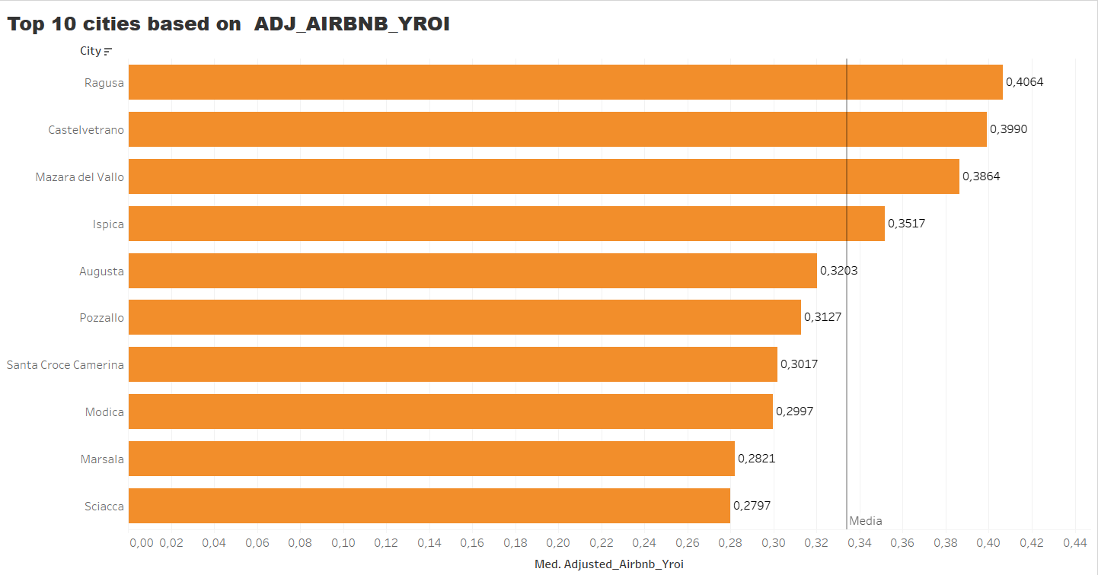

The chart shows the top 10 houses in relation to Adjusted_Airbnb_YROI, having set the condition in the filter for “City” to only include cities with more than 300 houses. As visible in the chart, the city with the highest Adj_Airbnb_YROI is Ragusa, with a value of 0.464. This means that (expanded explanation below). On the other hand, the city with the lowest Adj_Airbnb_YROI in the top 10 is Sciacca, with a value of 0.297. The chart also shows the average value of Adj_Airbnb_YROI for the houses considered, which is 0.3340. Thus, the values for the top houses in this ranking do not differ significantly from the overall average depicted in the chart. I chose this chart because it provides a simple visualization of the houses and also allows us to make comparisons with the average reference value for each house.

### Expanded Explanation of Adjusted_Airbnb_YROI:

ADJ_AIRBNB_YROI (Adjusted Airbnb Year-Over-Year Return on Investment) is a metric that measures the annualized return on investment for properties listed on Airbnb, adjusted for various factors that can influence profitability. These adjustments can include considerations such as seasonal fluctuations, changes in demand, varying occupancy rates, maintenance costs, and local market conditions.

For instance:

* **Ragusa** having an Adj_Airbnb_YROI of 0.464 indicates that, after accounting for the adjustments, properties in this city are generating a 46.4% annual return on investment. This high return suggests that Ragusa is a particularly lucrative market for Airbnb hosts, potentially due to high demand, optimal occupancy rates, or favorable market conditions.
* **Sciacca** with an Adj_Airbnb_YROI of 0.297 means that the annual return on investment, after adjustments, is 29.7%. While still profitable, it is lower compared to Ragusa, which might be due to slightly lower demand, higher competition, or other local factors affecting profitability.

The average Adj_Airbnb_YROI of 0.3340 across the houses indicates a typical annual return of 33.4% after adjustments. This benchmark helps to assess whether specific properties are performing above or below the average market performance.

Choosing this chart helps in visualizing and understanding how individual properties compare to the market average and each other, providing valuable insights for investors and hosts in making informed decisions.

**4.2 Top 10 cities based on RENT_YROI (consider only cities with more than 300 houses)**

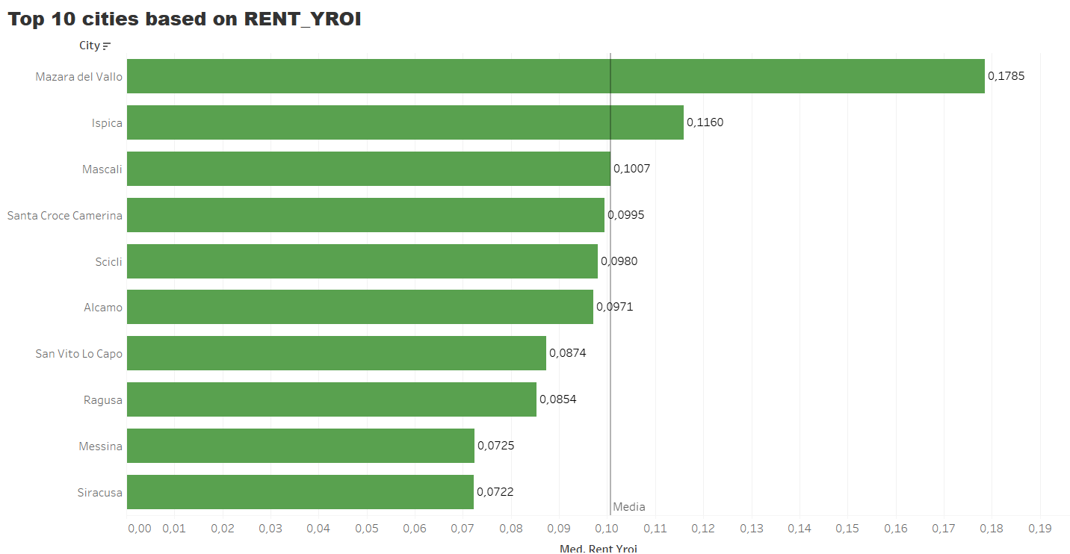

The chart shows the top 10 houses in relation to Rent_YROI, having set the condition in the filter for “City” to only include cities with more than 300 houses. As visible in the chart, the city with the highest Rent_YROI is Mazzara Del Vallo, with a value of 0.1785. This means that (expanded explanation below). On the other hand, the city with the lowest Rent_YROI in the top 10 is Siracusa, with a value of 0.0722. The chart also shows the average value of Rent_YROI for the houses considered, which is 0.1007. Thus, the values for the top houses in this ranking do not differ significantly from the overall average depicted in the chart. I chose this chart because it provides a simple visualization of the houses and also allows us to make comparisons with the average reference value for each house.

### Expanded Explanation of Rent_YROI:

Rent_YROI (Year-Over-Year Return on Investment) is a key metric that measures the annualized return on investment for rental properties. It reflects the income generated from renting out a property over a year relative to the property's value or the investment made. This metric helps property owners and investors understand the profitability of their rental investments on an annual basis.

#### Why Rent_YROI is Important:

1. **Performance Measurement**:
   * Rent_YROI helps in evaluating how well a property is performing in terms of generating rental income. A higher Rent_YROI indicates better profitability, making it a crucial metric for assessing the effectiveness of investment strategies.
2. **Investment Decisions**:
   * Investors use Rent_YROI to make informed decisions about purchasing, holding, or selling properties. Properties with higher Rent_YROI are typically more attractive as they promise better returns on investment.
3. **Benchmarking**:
   * By comparing Rent_YROI across different properties and cities, investors can identify which locations and types of properties yield the best returns. This helps in strategizing and optimizing investment portfolios.

#### Specific Insights from the Chart:

* **Mazzara Del Vallo** having the highest Rent_YROI of 0.1785 means that the properties in this city are generating a 17.85% annual return on investment from rental income. This high return suggests that Mazzara Del Vallo is a highly profitable market for rental properties, potentially due to factors like high rental demand, favorable rental rates, or optimal property management practices.
* **Siracusa** with the lowest Rent_YROI in the top 10 at 0.0722 indicates a 7.22% annual return on investment. While this is still positive, it is comparatively lower, possibly due to lower rental demand, higher property costs, or other market conditions affecting rental income.
* The **average Rent_YROI** of 0.1007 across the considered houses represents the typical annual return of 10.07%. This average serves as a benchmark to assess whether specific properties are performing above or below the market average.

### Why This Chart is Useful:

1. **Simple Visualization**:
   * The chart provides a straightforward visual representation of the top-performing houses in terms of Rent_YROI, making it easy to identify which properties are yielding the highest returns.
2. **Comparative Analysis**:
   * By including both the individual Rent_YROI values and the average, the chart allows for quick comparison, highlighting how each property stacks up against the average performance.
3. **Informed Decision-Making**:
   * Investors and property managers can use this chart to make data-driven decisions, such as focusing investment efforts on cities or types of properties with higher returns or investigating why certain properties perform better than others.

In conclusion, focusing on Rent_YROI provides valuable insights into the profitability of rental properties, aiding investors in maximizing their returns and optimizing their investment strategies.

**4.3 Top 5 types of house based on  ADJ_AIRBNB_YROI (consider only types with more than 100 samples)**

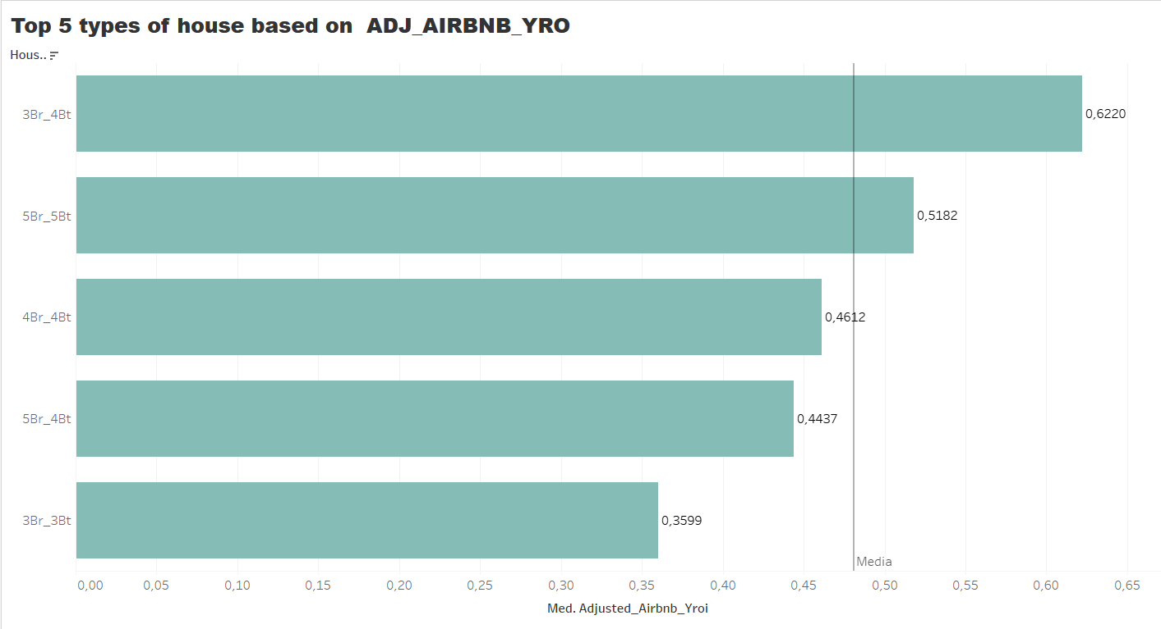

In this chart, we have displayed the 5 House Types in relation to Adj_Airbnb_YROI, considering only the House Types with more than 100 samples. This was made possible by placing the variable “Id” in the indicators, allowing us to count up to 100 samples for each House Type. This also helps us understand how many unique houses, identified by their Id, exceeded this sample value.

The House Type with the best Adj_Airbnb_YROI is the one with 3 bedrooms and 4 bathrooms (3 Br and 4 Bt), which has an Adj_Airbnb_YROI of 0.6220. The last in this ranking is the House Type with 3 bedrooms and 3 bathrooms (3 Br and 3 Bt), with an Adj_Airbnb_YROI of 0.3599. We also see the average Adj_Airbnb_YROI for these House Types, which is 0.4810.

### Expanded Explanation:

#### Understanding Adj_Airbnb_YROI:

Adj_Airbnb_YROI (Adjusted Airbnb Year-Over-Year Return on Investment) is a metric used to measure the annualized return on investment for properties listed on Airbnb, adjusted for various factors that can impact profitability. These adjustments can include seasonal variations, occupancy rates, maintenance costs, and local market conditions.

#### Insights from the Chart:

* **3 Br and 4 Bt House Type**:
  + Having an Adj_Airbnb_YROI of 0.6220 means that, after adjustments, these properties yield a 62.20% annual return on investment. This high return suggests that this type of house is particularly profitable, possibly due to high demand for larger properties or favorable pricing.
* **3 Br and 3 Bt House Type**:
  + With an Adj_Airbnb_YROI of 0.3599, these properties generate a 35.99% annual return on investment. While still profitable, it is lower compared to the top house type, potentially due to lower demand or higher maintenance costs for this configuration.
* **Average Adj_Airbnb_YROI**:
  + The average Adj_Airbnb_YROI of 0.4810 indicates that, on average, the properties considered in this analysis yield a 48.10% annual return on investment. This serves as a benchmark for evaluating individual house types' performance.

**4.4 Top 5 types of house based on  RENT_YROI (consider only types with more than 100 samples)**

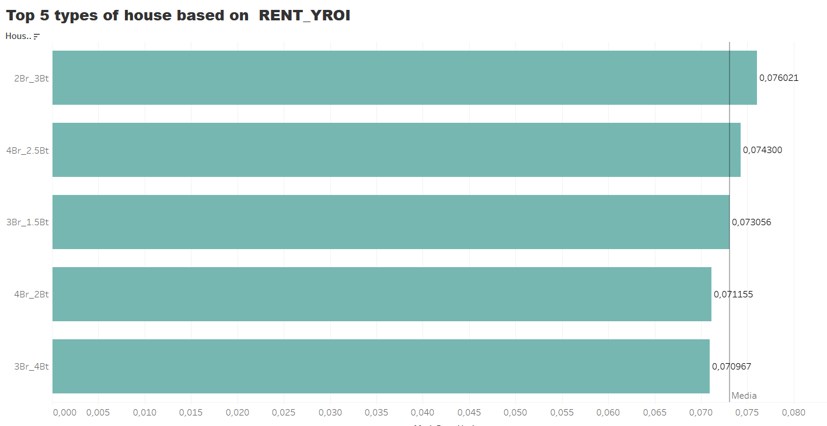

In this chart, we have displayed the 5 House Types in relation to Rent_YROI, considering only the House Types with more than 100 samples. This was made possible by placing the variable “Id” in the indicators, allowing us to count up to 100 samples for each House Type. This also helps us understand how many unique houses, identified by their Id, exceeded this sample value.

The House Type with the best Rent_YROI is the one with 2 bedrooms and 3 bathrooms (2 Br and 3 Bt), which has a Rent_YROI of 0.076. The last in this ranking is the House Type with 3 bedrooms and 4 bathrooms (3 Br and 4 Bt), with a Rent_YROI of 0.0709. We also see the average Rent_YROI for these House Types, which is 0.0731.

### Expanded Explanation and Comparison:

#### Understanding Rent_YROI:

Rent_YROI (Year-Over-Year Return on Investment) is a metric used to measure the annualized return on investment for rental properties. It reflects the income generated from renting out a property over a year relative to the property's value or the investment made. This metric is crucial for evaluating the profitability of rental investments on an annual basis.

#### Insights from the Chart:

* **2 Br and 3 Bt House Type**:
  + Having a Rent_YROI of 0.076 means that these properties yield a 7.6% annual return on investment from rental income. This indicates that this type of house is particularly profitable, likely due to a combination of high demand and favorable rental rates for this configuration.
* **3 Br and 4 Bt House Type**:
  + With a Rent_YROI of 0.0709, these properties generate a 7.09% annual return on investment. While still profitable, it is the lowest among the top 5 house types, possibly due to higher maintenance costs or slightly lower demand for larger properties.
* **Average Rent_YROI**:
  + The average Rent_YROI of 0.0731 indicates that, on average, the properties considered in this analysis yield a 7.31% annual return on investment. This serves as a benchmark for evaluating individual house types' performance.

**4.5 Comparison with Adj_Airbnb_YROI Results:**

1. **Performance Metrics**:
   * **Adj_Airbnb_YROI**: Measures the annual return on investment for Airbnb properties, adjusted for various factors affecting profitability.
   * **Rent_YROI**: Measures the annual return on investment for rental properties based purely on rental income.
2. **Top Performers**:
   * **Adj_Airbnb_YROI**: The highest return was for the house type with 3 bedrooms and 4 bathrooms (3 Br and 4 Bt), with an Adj_Airbnb_YROI of 0.6220.
   * **Rent_YROI**: The highest return was for the house type with 2 bedrooms and 3 bathrooms (2 Br and 3 Bt), with a Rent_YROI of 0.076.
3. **Lowest Performers**:
   * **Adj_Airbnb_YROI**: The lowest return among the top house types was for the house type with 3 bedrooms and 3 bathrooms (3 Br and 3 Bt), with an Adj_Airbnb_YROI of 0.3599.
   * **Rent_YROI**: The lowest return among the top house types was for the house type with 3 bedrooms and 4 bathrooms (3 Br and 4 Bt), with a Rent_YROI of 0.0709.
4. **Averages**:
   * **Adj_Airbnb_YROI**: The average was 0.4810, indicating a higher overall return after adjustments.
   * **Rent_YROI**: The average was 0.0731, reflecting the return based solely on rental income.

### Analysis and Implications:

1. **Higher Returns with Airbnb**:
   * The Adj_Airbnb_YROI values are significantly higher than the Rent_YROI values, indicating that properties listed on Airbnb may yield higher returns after adjustments for various factors. This suggests that short-term rentals might be more profitable compared to traditional long-term rentals.
2. **Variability in House Types**:
   * Different house types perform differently in terms of returns. For instance, a 3 Br and 4 Bt house type has the highest Adj_Airbnb_YROI but the lowest Rent_YROI among the top 5, highlighting the importance of considering property configuration in investment decisions.
3. **Benchmarking and Decision-Making**:
   * The averages provide useful benchmarks. Properties with returns above the average Adj_Airbnb_YROI or Rent_YROI are performing well relative to the market. Investors can use these benchmarks to assess the performance of their properties and make informed decisions about future investments.
4. **Market Trends**:
   * Understanding the differences in returns between Airbnb and traditional rentals can help investors adapt their strategies based on market trends and demand. For example, if the short-term rental market is booming, focusing on improving Adj_Airbnb_YROI might be more beneficial.

In conclusion, comparing Adj_Airbnb_YROI and Rent_YROI provides valuable insights into the profitability of different house types and rental strategies, helping investors optimize their portfolios for maximum returns.

1. **Additional Summary Charts**

**5.1 The top 5 types of houses in terms of ADJ_AIRBNB_YROI (consider only types with more than 20 samples) for the top 5 cities based on the Occupancy Rate (AVG, consider only cities with more than 300 houses).**

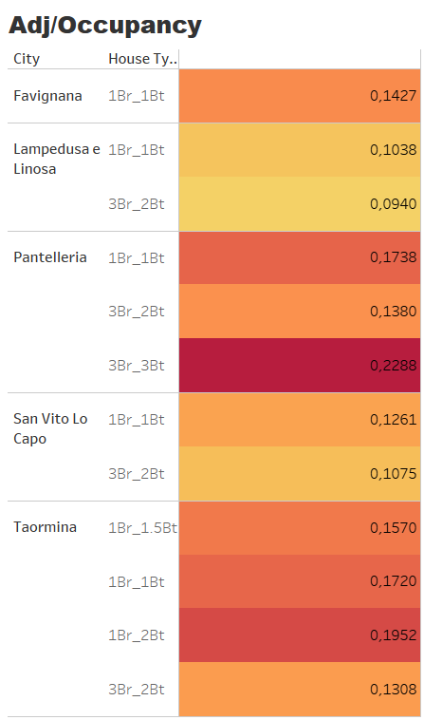

In this table, I have displayed and sorted the top 5 house types by Adj_Airbnb_YROI, considering only the house types with more than 20 samples, for the top 5 cities by Occupancy_Rate, considering cities with more than 300 houses. All these restrictions have been added to the filters, and as mentioned earlier, I counted the house types using the count of the Id for each House_Type.

The values we have are highest in Pantelleria, which has an average Occupancy Rate of 0.2288. This high value is immediately noticeable due to the color choices used, where a dark red color indicates a good Occupancy Rate. It is understandable that Pantelleria shows such high values, especially because it experiences high tourist inflow during the summer. The house type associated with this high occupancy rate is 3 bedrooms and 3 bathrooms (3 Br and 3 Bt).

On the other hand, lower occupancy rate values are visible in light yellow, such as 0.09 in Lampedusa, making a stark comparison with Pantelleria. Despite having the same house type (3 Br and 3 Bt), Lampedusa shows significantly lower occupancy rates.

Medium occupancy rate values in this ranking are identified by the orange color. Thus, the color scale used ranges from "Yellow-Orange-Red."

### Detailed Explanation:

#### Chart Setup:

1. **Top House Types**:
   * The focus is on the top 5 house types by Adj_Airbnb_YROI, ensuring that only house types with more than 20 samples are considered. This filtering ensures that the analysis is based on statistically significant data.
2. **Top Cities by Occupancy Rate**:
   * Only cities with more than 300 houses are included, and the top 5 cities are selected based on their average Occupancy Rate. This provides a focused view of the most significant markets.
3. **Use of Id for Counting**:
   * The Id variable is used to count the number of samples for each House_Type, ensuring accurate representation of the data.

#### Insights from the Data:

* **Pantelleria**:
  + **High Occupancy Rate**: The average Occupancy Rate is 0.2288. The high rate is indicated by a dark red color, which immediately draws attention. This high occupancy is likely due to the island's popularity during the summer season, attracting many tourists.
  + **House Type**: The dominant house type here is 3 bedrooms and 3 bathrooms (3 Br and 3 Bt).
* **Lampedusa**:
  + **Low Occupancy Rate**: An average Occupancy Rate of 0.09 is shown in light yellow, indicating lower performance compared to Pantelleria. Despite having the same house type (3 Br and 3 Bt), Lampedusa's occupancy rate is significantly lower, suggesting differences in demand or attractiveness between the two locations.
* **Color Coding**:
  + **Dark Red**: Represents high Occupancy Rates, indicating highly desirable locations and house types.
  + **Orange**: Represents medium Occupancy Rates, providing a balanced view of moderately performing properties.
  + **Light Yellow**: Represents low Occupancy Rates, highlighting areas or house types with less demand.

### Importance of This Analysis:

1. **Visual Clarity**:
   * The use of color coding makes it easy to quickly identify and compare performance across different cities and house types. This visual aid is crucial for spotting trends and outliers at a glance.
2. **Strategic Insights**:
   * Understanding which house types and cities yield the highest Adj_Airbnb_YROI and Occupancy Rates helps investors and property managers make informed decisions. For instance, focusing on Pantelleria with its high occupancy might be a strategic move for maximizing returns.
3. **Market Understanding**:
   * This analysis sheds light on the varying performance of similar house types in different locations. It helps to understand how market demand, seasonality, and other factors influence profitability.
4. **Optimization**:
   * Property owners can use these insights to optimize their listings, perhaps by adjusting pricing, enhancing amenities, or focusing marketing efforts on high-performing areas like Pantelleria.

In conclusion, this detailed analysis using filters and color coding provides valuable insights into the performance of house types across top cities, guiding better investment and management decisions in the Airbnb market.

**5.2 The top 5 cities in terms of  Occupancy Rate (consider only cities with more than 300 houses) for the top 5 types of house based on the ADJ_AIRBNB_YROI/RENT_YROI.**

In this table, we show the top 5 cities in terms of Occupancy Rate, considering cities with more than 300 houses, and also the top 5 House Types based on the Adj_Airbnb_YROI / Rent_YROI ratio (explained in detail below). I chose this table because it provides an instant and accurate visualization of the necessary data. Additionally, I included the Id parameter, which allows us to see the uniqueness of each house.

The colors of the Occupancy Rate range from a light color, indicating a low occupancy rate compared to others in the table, to dark blue, indicating a high occupancy rate.

For example, we can see that Taormina has an Occupancy Rate around 0.4994 with various house types such as 5 Br_5 Bt, 7 Br_5 Bt, and 8 Br_9 Bt. This can be justified by the fact that Taormina is one of the most touristic cities in Sicily, where many tourists, traveling in large groups, might choose houses with a higher number of bedrooms and bathrooms.

On the other hand, lower Occupancy Rates are visible, for example, in Noto, which has an average Occupancy Rate of 0.38 with a house type of 7 Br_8 Bt. This might be because Noto cannot be compared to Taormina in terms of Occupancy Rate, although, being a coastal location, it still has a relatively high occupancy rate.

### Explanation of Adj_Airbnb_YROI / Rent_YROI Ratio:

The **Adj_Airbnb_YROI / Rent_YROI ratio** is a crucial parameter for evaluating the profitability of properties listed on Airbnb versus traditional rentals. Here's what each component means:

* **Adj_Airbnb_YROI (Adjusted Airbnb Year-Over-Year Return on Investment)**: This metric measures the annual return on investment for properties listed on Airbnb, adjusted for various factors such as seasonal variations, occupancy rates, maintenance costs, and local market conditions. It reflects the profitability of short-term rentals.
* **Rent_YROI (Year-Over-Year Return on Investment from Rental Income)**: This metric measures the annual return on investment for properties based purely on long-term rental income. It indicates the profitability of traditional rentals.

By comparing these two metrics (Adj_Airbnb_YROI / Rent_YROI), we get a ratio that indicates how much more (or less) profitable a property is when rented out on Airbnb compared to traditional long-term rentals. A higher ratio suggests that Airbnb rentals are significantly more profitable, while a lower ratio indicates a smaller difference between the two rental strategies.

### Considerations:

1. **Tourism and Group Travel**:
   * Cities like Taormina, which have high Occupancy Rates, also feature house types with more bedrooms and bathrooms. This suggests that group travel is a significant factor, with tourists preferring larger accommodations. This trend can drive up both occupancy rates and profitability for these house types.
2. **Comparative Analysis**:
   * The difference in occupancy rates between cities like Taormina and Noto highlights the impact of tourism attractiveness on rental profitability. Taormina's higher rates reflect its popularity, while Noto, although also a coastal city, shows lower occupancy, possibly due to less tourist traffic.
3. **Strategic Investment**:
   * Investors can use the Adj_Airbnb_YROI / Rent_YROI ratio to make strategic decisions about property listings. For instance, properties in high-demand tourist areas with high ratios should be prioritized for Airbnb listings to maximize returns.
4. **Visual Insights**:
   * The use of color coding (light to dark blue) for occupancy rates provides a clear visual representation, making it easy to identify high and low-performing areas at a glance. This visual tool aids in quickly assessing market performance and identifying opportunities for improvement.
5. **Market Trends**:
   * The table provides insights into market trends, showing which house types and locations are performing well. Understanding these trends can help property managers and investors adjust their strategies to align with market demands and maximize profitability.

In conclusion, this table not only presents data in a clear and visually appealing manner but also provides valuable insights into the profitability of different house types and locations. By analyzing the Adj_Airbnb_YROI / Rent_YROI ratio and occupancy rates, stakeholders can make informed decisions to optimize their investments and rental strategies.

**6.Optimizing Real Estate Investments: Strategic Allocation of 1.2M Budget Across Multiple Cities**

**Supposing you have now 1.2M to buy houses.**

* **you have at least spend 700K;**
* **you can buy (at least) 7 to (no more) 10 houses.**
* **you must buy houses at least in 4 different locations;**
* **you can not buy more than 3 houses per location.**

I have created this dashboard using three distinct sheets. In the first sheet, I focused on property selection, ensuring a detailed analysis of available properties across different cities. The second sheet features an interactive map showcasing the selected properties, with a strong emphasis on coastal locations and their respective occupancy rates. Lastly, the third sheet examines the relationship between Adjusted Airbnb YROI and average local annual taxes, providing a comprehensive overview of financial considerations related to real estate investments.

#### Property Selection

In the first sheet of the dashboard, I concentrated on property selection analysis. I ensured that each house, city, and ID were distinct, ensuring clarity and uniqueness for each property. I included house type and house price to facilitate an informed selection of properties. This section is crucial for evaluating available options and identifying properties with the highest potential returns.

#### Map of Selected Properties

In the second sheet, I used an interactive map to visually represent the selected properties. I placed particular emphasis on coastal locations, which often exhibit high occupancy rates during the tourist season. The map also includes crucial information such as house price and house type for each property. This approach allows for a geographical assessment of properties and their income-generating opportunities.

#### Analysis of Adjusted Airbnb YROI and Local Annual Taxes

In the third sheet of the dashboard, I explored the relationship between Adjusted Airbnb YROI and average local annual taxes. This analysis provides a clear indication of the impact of local taxes on the net yield of properties. I used a side-by-side bubble chart to visually represent this relationship, where the color of the bubbles varies from light blue to dark blue based on the amount of local annual taxes. This allows for easy identification of locations with higher management costs and those with more moderate costs.

#### Specific Choices

**Avola:** I selected two properties in Avola, a location with relatively low annual local taxes (694 euros). This is a strategic choice considering the tranquility of the location and its appeal to tourist couples.

**Castellammare del Golfo:** This coastal city was chosen for a property with 4 bathrooms and 2 bedrooms, despite higher annual local taxes. The strong tourist flow during the summer justifies this selection.

**Catania:** Despite higher average annual local taxes (814 euros), I opted for a property in Catania due to its metropolitan nature and the tourism opportunities offered by the city.

**Other Coastal Locations like Marsala, Noto, Palermo, and Ragusa:** These locations were chosen for their high potential Adjusted Airbnb YROI and occupancy rates, despite varying local annual taxes. Ragusa, for example, with higher taxes, is attractive due to its increasing occupancy rate and tourist appeal.

#### Additional Considerations

**Strategic Property Selection:** The choice of coastal properties aims to maximize returns through high occupancy rates during the tourist season.

**Portfolio Diversification:** Diversifying properties across different cities reduces risk and offers more stable income streams through varying seasons and market conditions.

**Side-by-Side Bubble Chart to Visualize Local Annual Taxes:** The use of a side-by-side bubble chart makes it easy to understand the financial impact of local annual taxes on the overall yield of properties.

**Informed Real Estate Investment Approach:** This dashboard provides a comprehensive framework for making informed decisions about real estate investment, integrating financial and strategic considerations to maximize returns.

In conclusion, the detailed and strategic approach to property selection, combined with an in-depth analysis of financial variables such as local annual taxes and Adjusted Airbnb YROI, supports effective management of the real estate investment portfolio.

* **6.1 you have 200k available, and you must borrow the rest of the money with an interest rate ranging from [ 2 to 2.6] with 0.1 steps.**
* **Occupancy rate can vary from -5% to 5% to the expected one**

In this Dashboard, I based my analysis on various investment strategies. Specifically, I chose the French amortization method, which involves calculating loan payments and interest in a structured manner over a 30-year period. This approach helped me determine the selection of houses based on the investment and, more importantly, based on the most profitable return possible.

### Key Calculations and Parameters:

1. **Monthly Loan Payments**:
   * **Formula**: [House Price] * ([Interest Rate] / 100) / 12
   * **Explanation**: This calculates the monthly loan payments by multiplying the house price by the monthly interest rate (annual interest rate divided by 12). This is essential for understanding the cash flow required to service the loan. The French amortization method ensures that each monthly payment is the same, but the proportion of interest and principal changes over time, with interest being higher at the beginning and decreasing over the period.
2. **Return on Investment (ROI)**:
   * **Formula**: 30 * ([Annual Airbnb Rent] - [Local Annual Taxes]) - (([Interest Rate] / 100) * [House Price])
   * **Explanation**: This calculates the ROI over 30 years by taking the annual Airbnb rent minus local annual taxes, then subtracting the annual interest payment on the house price. This helps evaluate the long-term profitability of the investment.
3. **Total Cost of Loan**:
   * **Formula**: RUNNING_SUM(sum([House Price])) + ((RUNNING_SUM(sum([House Price])) - 200000) * [Interest Rate] / 100)
   * **Explanation**: This calculates the total cost of the loan by summing up the house prices and adding the interest cost. The formula considers a base amount of 200,000 units before applying the interest rate. This gives a clear picture of the total financial commitment over time.
4. **Percentage Occupancy Rate**:
   * **Formula**: ([Occupancy Rate] * 100) + [Occupancy_Rate_Variation_In_Percentage]
   * **Explanation**: This adjusts the occupancy rate to a percentage and includes any variations. This metric is crucial for predicting rental income potential.
5. **Occupancy Rate and Interest Rate Parameters**:
   * **Occupancy Rate Parameter**: This allows for adjusting the occupancy rate to see how different rates impact ROI.
   * **Interest Rate Parameter**: This enables adjustments to the interest rate to simulate different loan conditions and their impact on investment returns.

### Analysis and Decision-Making:

I aimed to calculate whether to use the property for Airbnb or traditional rent by using the ratio [Adjusted_Airbnb_YROI] / [Rent YROI]:

* **Values Greater than 1**: Indicate that Airbnb is more profitable than traditional renting.
* **Values Less than 1**: Suggest that traditional renting is more profitable.

I also created a scatter plot to group various House Types in relation to the Rent Ratio, helping me make the best choice based on these two important parameters.

Ho altresì posto la mia analisi anche per il costo medio per nott che comunque ci da un valore important per l’analisi e condiziona la nostra valutazione

### Investment Choices:

I chose houses with the highest ROI over the next 30 years. I also examined the average nightly rates to understand how these houses might perform during peak seasons, such as summer, for Airbnb. For example:

* **Sciacca and Scicli**: Both coastal locations with high ROI, suitable for Airbnb due to their popularity during the summer. The color scheme indicates:
  + **Blue**: High investment return.
  + **Orange**: Moderate investment return.
  + **Red**: Low investment return.

### Detailed Considerations:

1. **Investment Strategy**:
   * **Total Cost Per Investment**:
     + **Formula**: RUNNING_SUM(sum([House Price])) + ((RUNNING_SUM(sum([House Price])) - 200000) * [Interest Rate] / 100)
     + **Explanation**: This provides the total cost including cumulative house prices and interest, giving a comprehensive view of the total investment required.
2. **House Type and Symbol Representation**:
   * I created a sheet with identical symbols for the same houses but different colors if the House Type varied. Different symbols were used for different House Types, helping in quick visual identification.
3. **Occupancy Rate Map**:
   * This map shows the occupancy rates of the selected houses, emphasizing the importance of this metric for deciding on renting a house or using it for Airbnb. High occupancy rates generally indicate better rental income potential.
4. **Interest Rate Adjustments**:
   * The interest rate is a parameter that can be modified to see how changes affect the investment. Although we are considering a fixed interest rate for simplicity, real-world investments often have variable rates. This flexibility in the dashboard allows for better simulation and planning.
5. **Market Considerations**:
   * I intentionally did not use all available capital, recognizing that the current real estate market in Italy may not be very favorable. It might be wise to wait a few years for the market to become more active before making further investments.

### Conclusion:

The dashboard provides a detailed and strategic overview of potential investments in the real estate market. By incorporating various calculated fields, parameters, and visual aids, it allows for a comprehensive analysis of profitability and risk. This approach ensures informed decision-making and optimizes the investment portfolio for maximum returns.